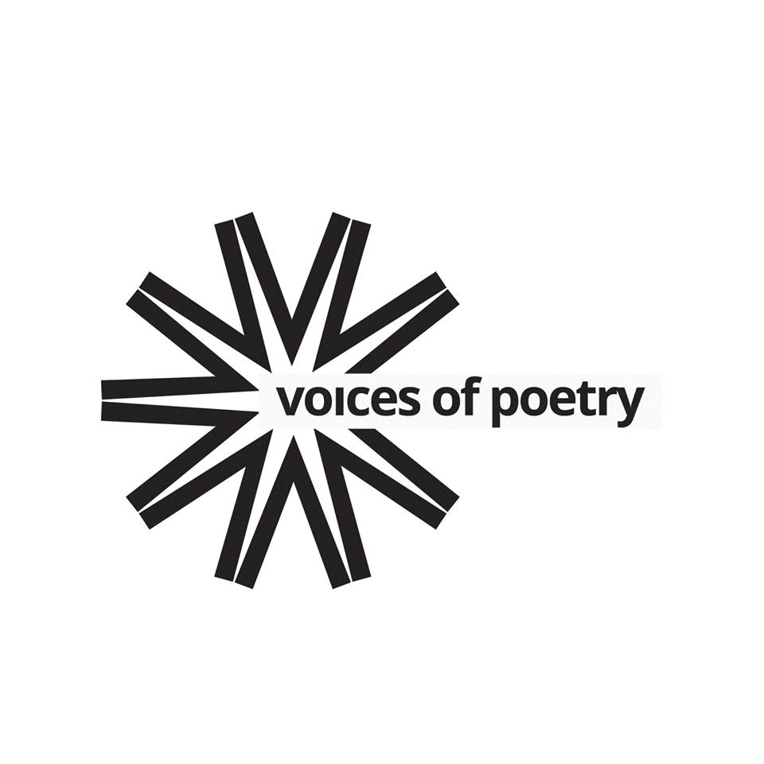

Voices of Poetry – Off the Wall
Tuesday, August 6, 2019 – 6:00 pm
Tao Water Art Gallery
1989 Main Street (Route 6A), West Barnstable, MA
(508) 375-0428 / www.taowatergallery.com
Suggested donation: $15 @ person.
Reservations suggested, but not required.

FOR IMMEDIATE RELEASE

Voices of Poetry (VOP) is delighted to present a summer evening of great poetry and music at Tao Water Art Gallery – a beautiful gallery owned by Dian Tong and her husband, artist Bao Lede – which boasts a museum-quality collection of contemporary Asian art. This event will feature a stellar array of poets – Julia Lisella, Tzynya Pinchback, Marika Preziuso & Suzanne Rancourt– and music by Lary Chaplan (violin) & Thomas Leidenfrost (accordion).

The Poets

Julia Lisella’s poetry books include Always (2014), Terrain (2007), and a chapbook, Love Song Hiroshima (2004). Her poems have been widely anthologized and appear in Alaska Quarterly Review, Ocean State Review, Valparaiso, Prairie Schooner, Crab Orchard Review, VIA: Voices in Italian Americana, Antiphon, Literary Mama, Pebble Lake Review, and others. She is Associate Professor of English at Regis College in Weston, MA and curates the Italian American Writers’ Association reading series at I AM Books, an independent bookstore in Boston’s North End. She also serves on the board of the Robert Creeley Foundation.

Tzynya Pinchback is author of the chapbook How to Make Pink Confetti (Dancing Girl Press). She has recent or forthcoming work in The Aurorean, Midnight & Indigo, Mom Egg Review, Up the Staircase Quarterly, and the 2019 Poets in Pajama Reading Series. Tzynya is on staff at The American Poetry Journal and writes about mermaids and surviving cancer at www.tzynyapinchback.com.

Marika Preziuso is Associate Professor of World Literature at the Massachusetts College of Art and Design. At MassArt, Marika teaches 20th century and contemporary post-colonial literature, particularly by migrant and diasporic writers, and speculative fiction of the uncanny, magic realism and Afro-futurism. She holds a Ph.D. in Literature from the Caribbean Diaspora and an M.A. in Gender, Society and Culture, both from the University of London. She is also the organizer of the Creative Counterpoints series, which began at MassArt in 2016. The series - which features symposia, art exhibitions, performances and artist talks - examines the intersections of creativity and difference.

Suzanne Rancourt is a veteran of the U.S. Marine Corps and the U.S. Army. She holds an M.F.A. in Writing from VT College of Fine Arts and a M.S. in Psychology from SUNY Albany. Suzanne’s work has appeared in Tupelo Press Native Voices Anthology, Bright Hill Press 25th Anniversary Anthology, Dawnland Voices, Northern New England Review, Bear Review, Three Drops Press, Snapdragon Journal, Muddy River Poetry Review, Ginosko, Cimarron Review, Callaloo, and numerous anthologies. Her first book, Billboard in the Clouds, was the winner of the Native Writers’ Circle of the Americas First Book Award. Her second book, murmurs at the gate, was published this past May.

The Musicians

Lary Chaplan started studying and playing violin in Los Angeles with Ben Berzinsky, a previous member of the New York Philharmonic and teacher of Albert Einstein. He joined the California Jr. Symphony in 1959 where he remained a member for nine years. He then moved to NYC where he attended CUNY and received a Bachelor of Fine Art degree. He played as a freelance violinist in New York for 18 years, working with various symphonies, pit orchestras, rock bands, and jazz bands. In 1989, Lary moved to Cape Cod and joined the Cape Symphony, the Plymouth Philharmonic, and Woods Hole Choral Society.

Thomas Leidenfrost is an accordionist, vocalist, and actor living on Cape Cod. He studied theater at Massachusetts College of Liberal Arts, but his musical pursuits are mostly self-taught. Tom has performed at various venues on the Cape, including The Mews Restaurant &amp; Café in Provincetown; the UU Meeting House of Chatham; and Cape Repertory Theatre in Brewster.

VOP was formed by Pushcart Prize-nominated poet and poetry activist Neil Silberblatt. Since 2012, VOP has organized and presented more than 200 poetry events in four states: NY, NJ, CT and MA. Those events – which have featured Poets Laureate and Pulitzer Prize winners/nominees, as well as those who have not (yet) published a word - have been presented at numerous venues, including Provincetown Art Association & Museum; The New Britain Museum of American Art in New Britain, CT; The Mount – Edith Wharton’s home in Lenox, MA; and The Rubin Museum of Art and McNally Jackson Books in NYC.

Suggested donation: $15 @ person. No one will be denied admission to this event due to lack of funds.

